**WORKING INSTRUCTIONS**

|  |  |
| --- | --- |
| **Doc Nr.:** | **NCT LAB** |
| **Version:** | **Continental TCI, Bangalore** |
| **Impl. Date:** | **Model: Toellner TOE8815 (Arbitrary Power Supply).** |

|  |
| --- |
| **Safety Instructions/ ESD/3S** |
| 1. **Always follow working instruction** 2. **Clean the machine table before usage and clean the equipment if any dirt and dust found.** 3. **After completing the work do not keep the fixtures, test components on the machine table.**  |  |  |  | | --- | --- | --- | | **S1 (Seiri)** | **S2 (Seiton)** | **S3 (Seisou)** | | **Prepare needed tools** | **Keep everything tidy** | **Always keep clean** | |

|  |
| --- |
| **Unusual Case** |
| **If the equipment functions abnormally, e.g. strange sounds, warning signal or something looks unusual:**   |  | | --- | | **Stop machine – Inform - Waiting** |   **Stop the machine**  **Inform to the lab incharge**  **Wait for the decision** |

**Toellner TOE8815 (Arbitrary Power Supply):**

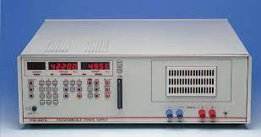

**Safety labels on products:**

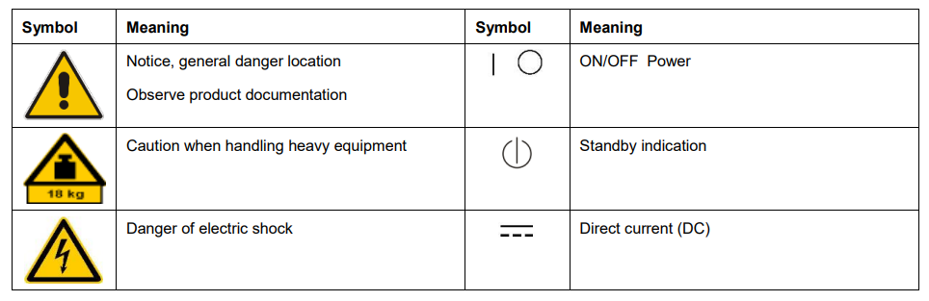

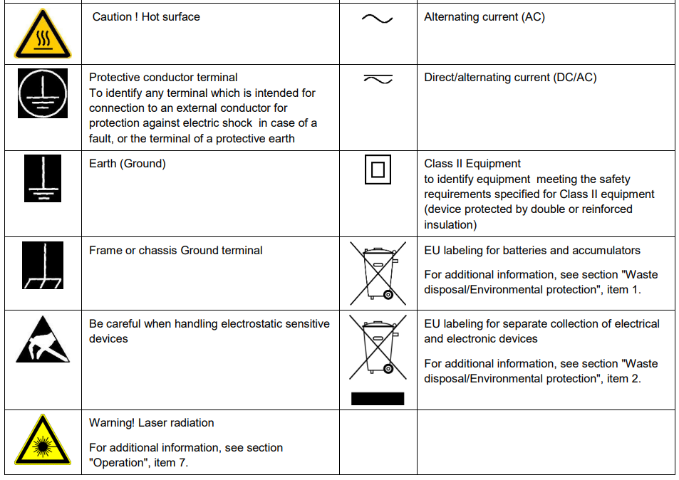

**Risk of instrument damage during operation:**

An unsuitable operating site or test setup can damage the instrument and connected devices. Ensure the following operating conditions before you switch on the instrument:

* Make sure that the nominal voltage setting on the product matches the nominal voltage of the AC supply network.
* Never use the instrument in dusty or damp conditions, in an explosion hazard area, or near aggressive chemicals. The ambient temperature and humidity must not exceed the ranges specified for the equipment.
* The instrument should be dry and shows no sign of condensation.
* The instrument can only be operated with a properly grounded safety socket outlet.
* Never use a cheater plug or other means to defeat or disconnect the protective ground lead.
* Check the power cable for damage and replace it if necessary. The power cord must be plugged in before signal circuits are connected.
* Before each measurement, check the instrument for proper operation using a known signal source or sample.
* Signal levels at the input connectors are all within the specified ranges.
* Signal outputs are correctly connected and are not overloaded.

1. **Power Button:** This button turns the power supply on and off. It's usually the first button you press to activate the unit.
2. **Voltage and Current Controls:** These buttons or knobs allow you to set the desired output voltage and current. You can usually increment or decrement these values based on your requirements.
3. **Output Enable/Disable:** This button or switch enables or disables the output of the power supply. When the output is disabled, the power supply won't provide voltage or current to your connected device.
4. **Memory/Recall Buttons:** Some power supplies come with memory banks or recall buttons. These allow you to save and quickly recall specific voltage and current settings for different experiments or devices.
5. **Function/Mode Selector:** If your power supply offers different operating modes (e.g., constant voltage, constant current, or arbitrary waveform generation), this button allows you to select the mode you want to use.
6. **Fine and Coarse Adjustments:** These controls help you make precise adjustments to voltage and current output. The "fine" adjustment provides smaller increments, while the "coarse" adjustment offers larger changes.
7. **Set/Enter Button:** This button is used to confirm your selected settings for voltage, current, or other parameters.
8. **Display Screen:** The display screen shows you the current output voltage, current, and other relevant information about the power supply's status.
9. **Overvoltage/Overcurrent Protection:** Some power supplies have buttons or settings for setting overvoltage and overcurrent protection limits to prevent damage to your connected device.
10. **Local/Remote Control:** This button or switch allows you to switch between local control (manual operation from the front panel) and remote control (usually through a computer interface or external signal).
11. **Auto-Range:** This feature allows the power supply to automatically select the best voltage or current range based on your input or requirements.

**Voltage characteristics** **of any type**

Almost any power supply characteristics can be generated using the power supplies of the TOE 8805 to TOE 8865 series. Amongst other functions, these units deliver extremely precise DC voltages, permit short, defined voltage dips, or permit spikes superimposed on a previously set DC voltage up to an output power of 1920 W. These power supplies work like an arbitrary function generator, although they are unipolar with a high output power up to 1920 W. All models have a modular design consisting of an intelligent control unit with power boosters connected in parallel, each with an output power of 320 W.

**Operating modes**

Based on a two-processor architecture, the power supplies provide a range of operating modes. In the “power supply“ function, these units can be used to generate extremely exact DC voltages and direct currents up to 80 V and 100 A. The maximum resolution is 1 mV or 1 mA. In the “arbitrary“ function, these units can be used to generate any voltage and current curves with a maximum of 1,000 turning points.

**Arbitrary function**

In arbitrary mode, any voltage or current characteristics can be generated, where a curve is defined by min. 2 and max. 1000 points. The duration of the turning points can vary between 200 µs and 100 s. Periods between 400 µs and 100,000 s (28 h) can thus be achieved. Permanent holding at one turning point is also possible. It is appropriate that different hold times can be assigned to each waveform memory location within a period. In continuous mode, the instrument repeats a saved function any number of times; in burst mode, the execution of curves can be selected between 1 (single shot) and 255.

**General data Arbitrary power supplies :**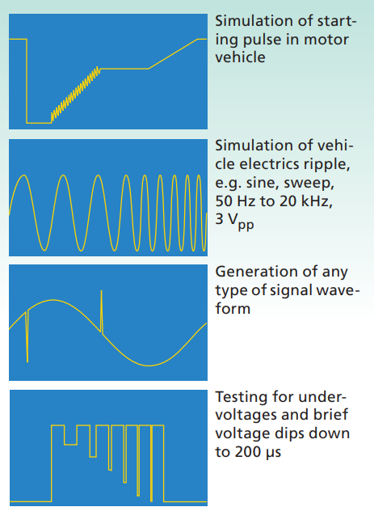

**Generation of curves**

Almost any power supply characteristic can be generated in a few minutes without any special preliminary knowledge. For example, the vehicle electrics characteristic during starting-up of an internal combustion engine according to DIN 40839 can be manually programmed and saved within a few minutes. Programming via the IEEE interface is equally possible, but unnecessary in this application since the integral interpolation function carries out all required calculations. A further possibility for generating curves is using the supplementary TOE 9030 memory card drive. This drive can be used for easy programming of curve characteristics for all arbitrary TOELLNER power supplies. By means of an easy-to-use Windows program, it is possible in the TOE 9030 memory card drive to program SRAM memory cards according to the Jeida standard 4.0 (PCMCIA cards) with a capacity of up to 2 Mbyte. The memory cards can be subsequently inserted into the Toellner arbitrary power supplies to import the data.

**Memory card**

The programmed function can be saved on a memory card with a capacity of up to 2 MB for later use. A maximum of 128 curves with 1000 turning points each can therefore be saved on one single card.

**Display**

The voltage and current values are displayed on two 5-digit 7-segment displays, and are also available as a standardized variable in the form of monitor voltages.

**Remote control:**

GPIB and analog All units can be remote-controlled as standard in analog mode and via GPIB interfaces. Up to 12 data sets can be read per second; driver software for LabView permits problem-free integration into systems and convenient operation.

**Applications**

The possible applications for these versatile power supplies are just as comprehensive as their functions. They can be used wherever the response of electronic systems is to be checked for irregularities in the supply voltage. In a vehicle, for example, the individual units or modules must not be affected whatsoever by any voltage dips during the start-up procedure or voltage peaks when switching off inductive loads. Further applications include the EMC testing of components or modules, the testing of electromagnetic relays, contactors or heavy-duty relays, the testing of anti-skid and airbag systems, and the checking of start-up electronics. All instruments from the TOE 8805 to 8865 range can provide all required voltage characteristics without problem, where short-circuit currents can be drawn up to three times the rated current.

**Display**

**Voltage/current**: separately on two 5-digit displays

**Address:** IEEE device address or memory address

**Memory for instrument**

settings Memory locations: 100 complete instrument settings for power supply mode and one setting in the non-volatile memory for the instrument status when switching off

**Arbitrary function**

**Turning points:** 2 to 1000

**Turning point data**: Voltage, current and step size

**Step size:** 200 µs to 100 s and ∞, separately adjustable for each turning point.

**Sequence mode:** Continuous or burst with 1 to 255 cycles

**Triggering:** Manually on keypad, remote controlled by bus command, or external trigger (TTL)

**Saving:** 1 complete function sequence with the data for 1000 turning points is saved in the non-volatile memory; external saving of function sequences on SRAM memory card according to JEIDA 4.0 standard with max. capacity of 2 Mbyte

**IEEE bus control Interface standard**:

Electrically isolated; according to IEEE 488.1 Software standard: According to IEEE 488.2 Functions: AH1, SH1, L4, T6, SR1, PP1, RL1, DC1, DT1, E1, C0 Device address: 0 to 30 Measuring rate: > 8 measurements/s for voltage and current, > 12 measurements/s for voltage or current Setting times: With a measurement taking place, extension of setting times by up to 100 ms

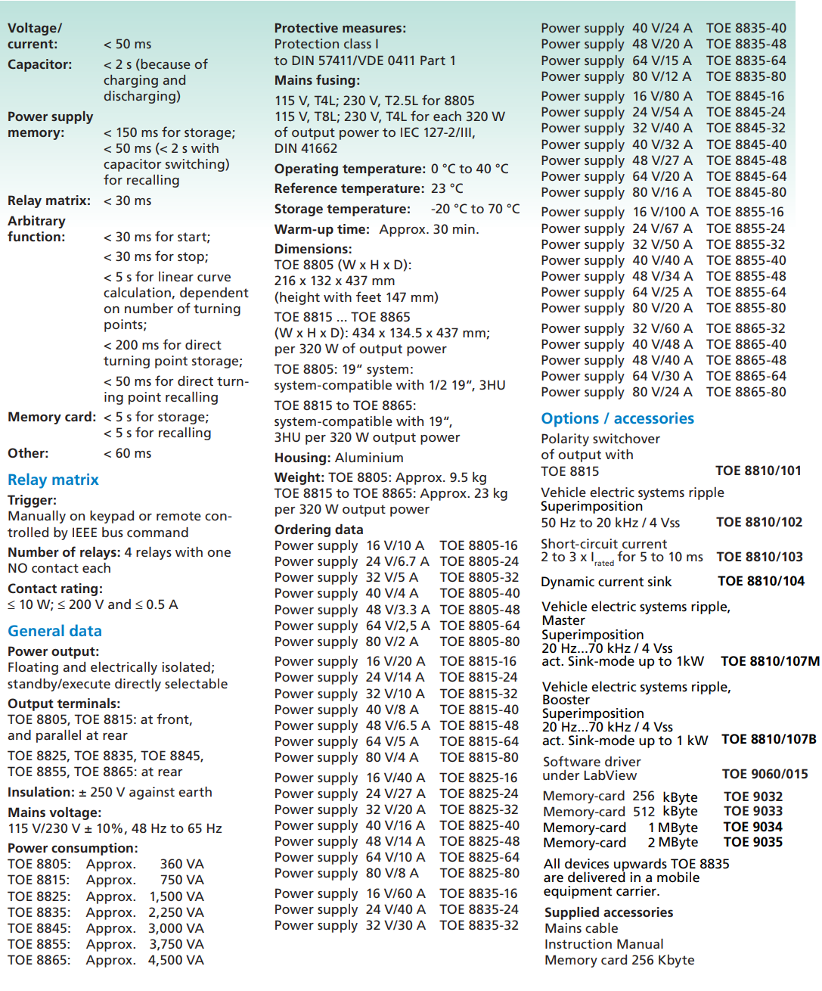

**Specifications Arbitrary power supplies :**

